BME 301 Name:
Exam 1
February 12, 2004

The exam consists of 10 questions. Show all work to receive credit. Clearly organize your work and draw a box around your final answers. NEATNESS COUNTS! Good Luck!

Problem 1 (5):

Problem 2 (5):

Problem 3 (20):

Problem 4 (10):

Problem 5 (20):

Problem 6 (5):

Problem 7 (5):

Problem 8 (10):

Problem 9: (10):

Problem 10 (10):

Total (100):

- a) Which would you expect to be higher: the incidence of the flu or the prevalence of the flu? Why?

- Which would you expect to be higher: the incidence of HIV/AIDS or the prevalence of HIV/AIDS? Why?

- Discuss three advantages and three disadvantages of the single payer Canadian system of health care financing compared to that of the multi-payer US system of health care financing.

- Use the information in the chart to answer the questions that follow.

Country | Population | Gross Domestic Product (GDP)  Per Capita | Total Health Expenditure Per Capita | Estimated annual incidence rate of tuberculosis per 100,000 population
Brazil | 172,558,000 | $7,548 | $631 | 64
India | 1,025,095,000 | $1,461 | $71 | 178
Uganda | 24,022,000 | $932 | $36 | 324

(a) For each of the three countries shown, calculate the approximate number of new cases of tuberculosis each year.

(b) Make a graph that shows estimated annual incidence rate of tuberculosis (per 100,000 population) vs. total health expenditure per capita for these three countries. Include a title and labels.

(c) For each of the three countries shown, calculate the percentage of the gross domestic product (GDP) that is spent on health expenditures.

(d) Make a graph that shows percentage of GDP spent on health expenditures vs. GDP per capita for these three countries. Include a title and labels. Based on your knowledge of the U.S. health care system, describe where you think the United States would lie on this graph.

- The graphs below show how the incidence rate and the mortality rate for breast cancer have changed over the past 25 years. Between 1980 and 1987, incidence increased almost 4% per year.

  - What was the most important factor contributing to this increase in incidence?

  - Since 1989, the mortality rate of breast cancer has been decreasing among Caucasian women. What are the most important factors which have contributed to his decrease?

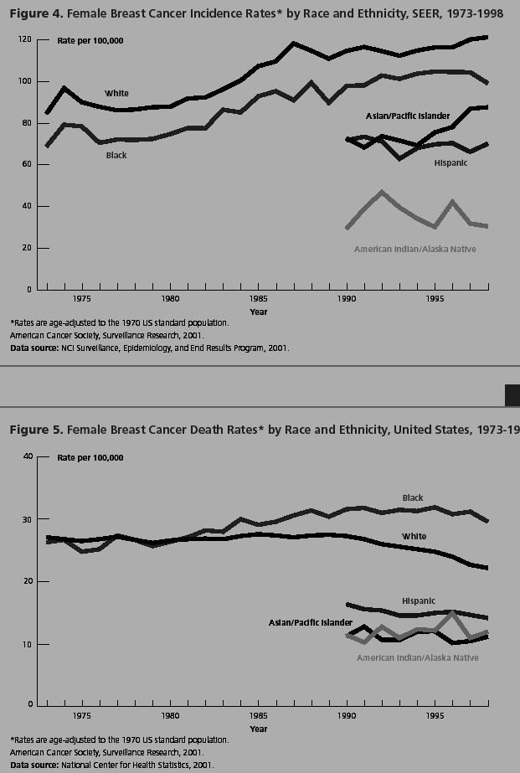

- When detected early, ovarian cancer is curable for 95% of women. Unfortunately, in the majority of cases, ovarian cancer is not detected until widespread metastasis has occurred. In this circumstance, ovarian cancer is fatal approximately 63% of the time. The American Cancer Society estimates that there will be about 25,580 new cases of ovarian cancer in the United States in 2004. About 16,090 American women will die of the disease in 2004. On average, 22 years of life are lost when a woman dies of ovarian cancer. You have developed a new blood test that can detect ovarian cancer in the earliest possible stages. Each blood test costs $200 to perform. There are 292 million Americans, approximately 70 million of whom are women over age 40.

  - How much money would we spend annually if all women over age 40 were screened with this new test?

  - Calculate the annual mortality rate of ovarian cancer without the use of the new test. Compare this to the expected annual mortality rate of ovarian cancer with the use of the new test.

  - If the new test was used, how many years of life would be gained?

  - If this test was administered annually to all women over age 40, how many $ would we spend per year of life gained?

  - Based on your answer to part d and our discussions in class, do you think this test would be adopted in the developed world? In the developing world? Explain your reasoning.

- Describe the clinical course of HIV infection, including the major steps from initial infection to full-blown AIDS.

- The figure below shows the major steps that occur when HIV infects a CD4+ lymphocyte. Three types of drugs have been developed to fight HIV infections. Indicate on the figure where in the viral life cycle these three types of drugs act. In one sentence each, describe how the drugs work.

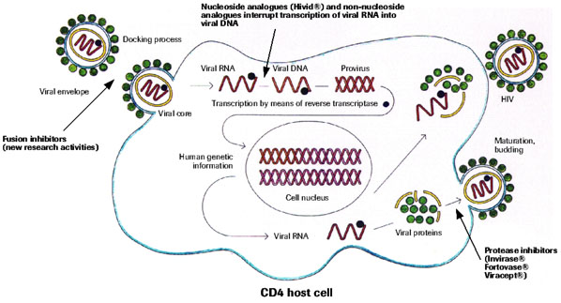

- What are the four major types of health insurance plans? Give a one-sentence description of the features of each one.

- High dose chemotherapy followed by bone marrow transplant is an example of a therapy that initially generated much excitement and hope, but was later found to not be effective.

  - Why did people initially believe that high dose chemotherapy would be effective for metastatic breast cancer?

  - Why is a bone marrow transplant necessary following high dose chemotherapy?

- Health care costs have risen dramatically in the US. At the same time, the number of people without health insurance has been rising. A number of plans to reform health care have been proposed in response to these pressures.

  - What are the three major factors currently responsible for increases in health care costs in the United States?

  - Whether health care reform in Oregon was a success or not has been the subject of much debate. Give two arguments for each side.
EXTRA CREDIT:

- Is the fish tank in Dr. Richards-Kortum's office a fresh or salt-water tank?

- Who is on the front of the BME301 official t-shirt?

- What is the saddest book that Dr. RRK has ever read?

